Representing Ourselves as Unique Individuals

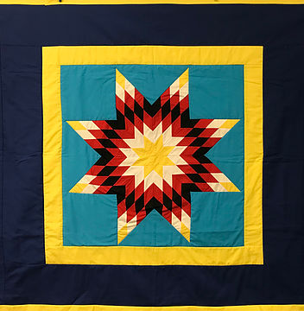

Name:________________________________

**First….** As Miss J is reading you the story “The Name Quilt,” come up with three words, phrases or images that stand out to you. Place your ideas and thoughts in the 3 stars below and be ready to share your ideas.



If you had a patch on a name quilt, describe what your name patch would look like? (Note: remember to use adjectives in your description.) ________________________________________________________________________________________________________________________________________________________________________________________________________________  
____________________________________________________



________________________________________________________________________________________________________________________________________________________________________________________________________________

**Second.…** You will be creating a piece of a star quilt in the shape of a diamond. Create a design on the diamond that represents who you are. This should be a rough sketch before moving onto your good copy (your piece of art). Decide colors, pictures and an overall design. Be sure your name is incorporated into your design. Please refer to your ‘Who am I?’ organizer in your ‘Who am I?’ booklet to help you determine what to add to your diamond to create the best representation of your identity.

**Third…**Put up your hand and show Miss J your rough sketch to receive your card stock diamond.

**Now…** Go through the checklist to make sure your design meets all the requirements and your diamond is well thought out and complete.

|  |  |  |
| --- | --- | --- |
| Criteria | Yes | No |
| Name:  *Is my name incorporated into my design?* |  |  |
| Elements/Personal Representation:  *Do I have at least three elements on my diamond that represent who I am?* |  |  |
| Connecting Prior Knowledge:  *Does each part of my design connect to what I have learned about myself throughout this unit?* |  |  |
| Communication  *Can I explain how each part of my design represents who I am as a person?* |  |  |
| Aesthetic (Bonus):  *Will my diamond stand out because of its colorful and thoughtful design?* |  |  |

**Finally….** Explain your design. There is a writing prompt below to help you if you are not sure how to get started.

|  |
| --- |
| *Writing Prompt:*  *My diamond has many elements that represent who I am. The first element is____________ this represents my identity because …. (add your explanation) The second element is _______________, represents my identity because……. ((add your explanation) (Continue listing the elements on your diamond and explaining how they represent who you are)* |
| *Written Response:*  Tell me about your diamond art. Why did you choose to decorate it the way you did? What does it say about your identity? How does it represent who you are?  ___________________________________________________________________________________________________________________________________________________________________________________________________________________________________________________________________________________________________________________________________________________________________________________________________________________________________________________________________________________________________________________________________________________________________________________________________________________________________________________________________________________________________________________________________________________________________________________________________________________________________________________________________________________________________________________________________________________________________________________________________________________________________________________________________________________________________________________________________________________________________________________________________________________________________________________________________________________  __________________________________________________________________________________________________________________________________________________________________________________________________________________________________________________________________________________________________________________________________________________________________________________________________________________________________________________________________________________________________________________________________________________________________________________________________________________________________________________________________________________________________________________________________________________________________________________________________________________________________________________________________________________________________________________________________________________________________________________________________________________________________________________________________________________________________________________________________________________________________________________________________________________ *_______________________________________________________________________________________________________________________________________________________________________________________________________________________________________________________________________________________________________________________________________________________________________________________________________________________________________________________________________________________________________________________________________________________________________________________________________________________________________________________________________________________________________________________________________________________________________________________________________________________________________________________________________________________________________________________________________________________________________________________________________________________________________________________________________________ _________________________________________________________________________________________________________________________________* |